Experiment Title: 4

Student Name: Suleiman Saeed Mushed UID:19BCS3527
Branch: 19AITIS-1 Lab Group: A
Semester: 5th
Date of Performance:
Subject Name: Advance Programming lab
Subject Code: CSP-347

1. Aim/Overview of the practical: Advanced Programming Lab

2. Task to be done:
1. You are given a string containing characters A and B only. Your task is to change it into a string such that there are no matching adjacent characters. To do this, you are allowed to delete zero or more characters in the string. Your task is to find the minimum number of required deletions. For example, given the string s=AABAAB, remove an A at positions 0 and 3 to make s=ABAB in 2 deletions.
2. A company has following details of their employees in the file 'emp.dat'
a. Emp Id
b. Emp Name
c. Emp Address
d. Emp Dept (Admin/Sales/Production/IT)
e. Emp Phone
f. Emp Age
Write a C++ program to read the above file. Create new file such as Adm.dat, Sal.dat, Pro.dat, IT.dat respectively to store the employee details according to their department.

3. Algorithm/Flowchart (For programming based labs):
i)Start
ii)make a class named as emp.
iii)make a variable from these field and take the input from the user.
Emp Id
Emp Name
Emp Address
Emp Dept (Admin/Sales/Production/IT)
Emp Phone
Emp Age
iv)If file is present then it will be printed as “Record inserted”. Otherwise “Failed to insert into the file”.
v)Take the input from user that how much data user want to insert.
vi)Exit.

4. Steps for experiment/practical:

#include<iostream>
#include<string.h>
#include<stdio.h>
#include<cstdlib>
#include<fstream>

using namespace std;
char empfile[30] = "Worksheet.txt";
char ITfile[20] = "w.txt";
char Adminfile[25] = "admin.txt";
char Prodfile[30] = "prdction.txt";
char Salesfile[30] = "file.txt";
class emp1
{
int empid;
char name[30];
char address[60];
int age;
public:
char dept[15];
void get();
char *getdept()
{
return dept;
}
};
void emp1::get()
{
cout<<"\n Enter the ID of the employee:-";
cin>>empid;
cout<<"\n Enter Employee name:-";
cin>>name;
cout<<"\n Enter employee address:-";
cin>>address;
cout<<"\n Enter Department Name of the Employee(Admin/Sales/IT/Production):-";
cin>>dept;
cout<<"\n Enter employee age:-";
cin>>age;
}
void insert()
{
emp1 e1;

ofstream fout;
fout.open("Worksheet4.txt",ios::in | ios::out | ios::binary | ios::app | ios::ate);

if (fout.fail())
{
cout<<"\n Unable to Open the File!!!";
goto err;
}
e1.get();
fout.write((char *)&e1,sizeof(e1));
if(fout.tellp()%sizeof(e1)==0)
{
cout<<"\n Record Inserted !!!"<<endl;
}
else
{
cout<<"\n Insertion Failed !!!";
goto err;
}
err:
fout.close();

}
void sort()
{
emp1 e1;
ofstream adm,sal,pro,it;
ifstream fin;
adm.open(Adminfile, ios::out | ios::binary | ios::app);
sal.open(Salesfile, ios::out | ios::binary | ios::app);
pro.open(Prodfile, ios::out | ios::binary | ios::app);
it.open(ITfile, ios::out | ios::binary | ios::app);
fin.open(empfile, ios::in | ios::binary);
while(fin.read((char *)&e1,sizeof(e1)))
{
if(strcmp(e1.getdept(),"Admin")==0)
{
adm.write((char *)&e1,sizeof(e1));
cout<<"\n Record Inserted into ADMIN File!!!";
}
else if(strcmp(e1.getdept(),"Sales")==0)
{
sal.write((char *)&e1,sizeof(e1));
cout<<"\n Record Inserted into SALES File!!!";
}
else if(strcmp(e1.getdept(),"IT")==0)
{
it.write((char *)&e1,sizeof(e1));
cout<<"\n Record Inserted into IT File!!!";
}
else if(strcmp(e1.getdept(),"Production")==0)
{
pro.write((char *)&e1,sizeof(e1));
cout<<"\n Record Inserted into Production File!!!";
}
else
cout<<"\n Insert Correct Record!!!";
}
fin.close();
adm.close();
sal.close();
it.close();
pro.close();
}
int main()
{
int n;
cout<<"\n How many Records you want to insert:-";
cin>>n;
for(int i=0; i<n; i++)
{
insert();
}
sort();
return 0;
}

6. Theorems /Formulas used etc:

No Formulas.

7. Result/Output/Writing Summary:

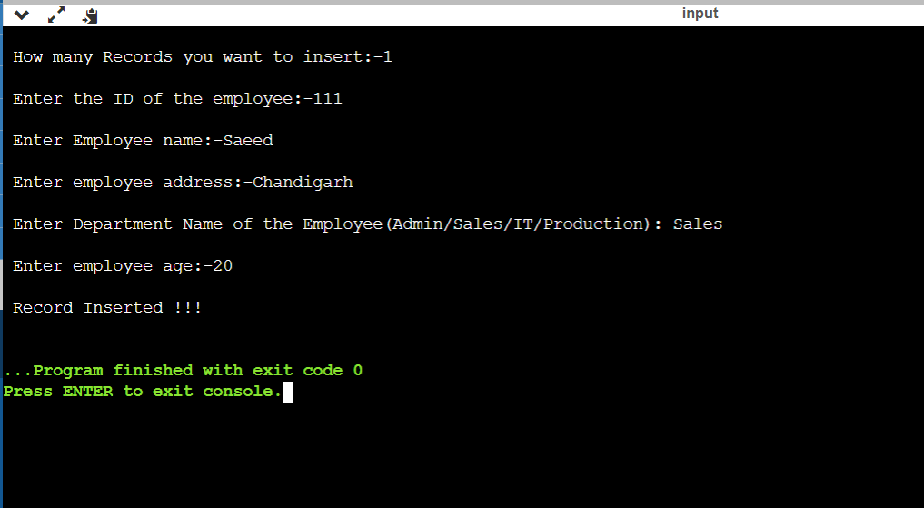

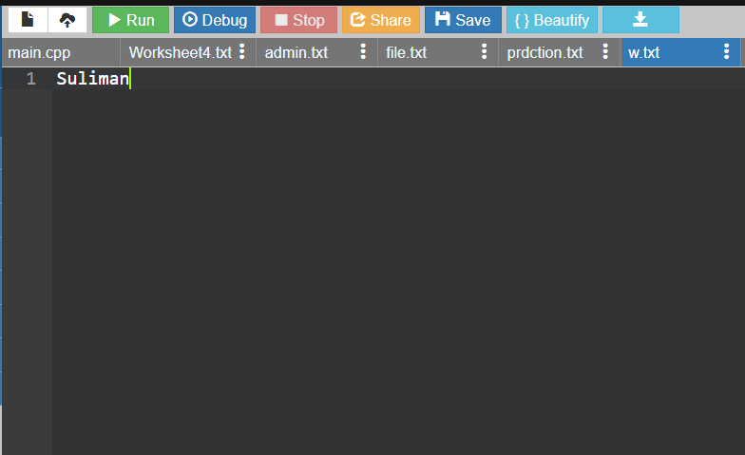

Conclusion/ Remarks:
1.In this program , we learnt about the basics of file handling.
2. In this program , we learnt the various types of file handling.
3. In this program , we learnt the program related to file handling.
4. In this program , Various looping concepts are cleared.

